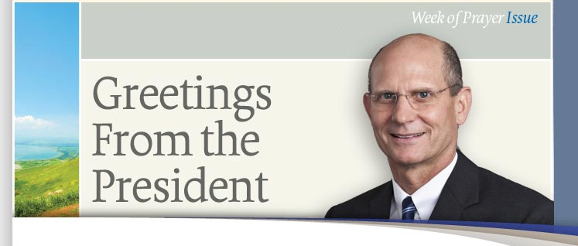
H
ow is your Christian life? Does each day draw you closer to the Lord, or do you seem to be stuck in your relationship, or possibly even drifting away from Him?
This year’s Week of Prayer readings, “And They Followed Him,” focus on “Revival and the Christian Life,” and how we can have a vibrant, happy, and rewarding relationship with God. You won’t want to miss a day of these special readings that go beyond outward appearances and aim straight for the heart.
In our first Sabbath reading we sit at the feet of Jesus as He reveals the blueprint for Christian living in the Sermon on the Mount. During the weekly readings Pastor Larry Lichtenwalter encourages us to examine who we are, why we do what we do, and why it matters. Looking at practical lifestyle matters such as materialism, sexuality, entertainment, interpersonal relationships, truthfulness, and integrity, Pastor Lichtenwalter focuses on how the Holy Spirit can renew and revive all who are willing to follow His leading. Bringing the entire “Revival and the Christian Life” theme together, we will end the week with inspired counsel from the pen of Ellen White.
If you have younger ones in the home (of if you simply enjoy great stories!) you won’t want to miss the accompanying children’s readings, written by Saustin Mfune, associate director of the Children’s Ministries Department at the General Conference.
May the Lord bless you as we come together as a world church to study and pray during this special Week of Prayer.

Ted N. C. Wilson
President

